[PIONEER](https://www.virtualdj.com/manuals/hardware/pioneer.html) - [DDJ-1000](https://www.virtualdj.com/manuals/hardware/pioneer/ddj1000.html) - [LAYOUT](https://www.virtualdj.com/manuals/hardware/pioneer/ddj1000/layout.html)

**DECK CONTROLS**

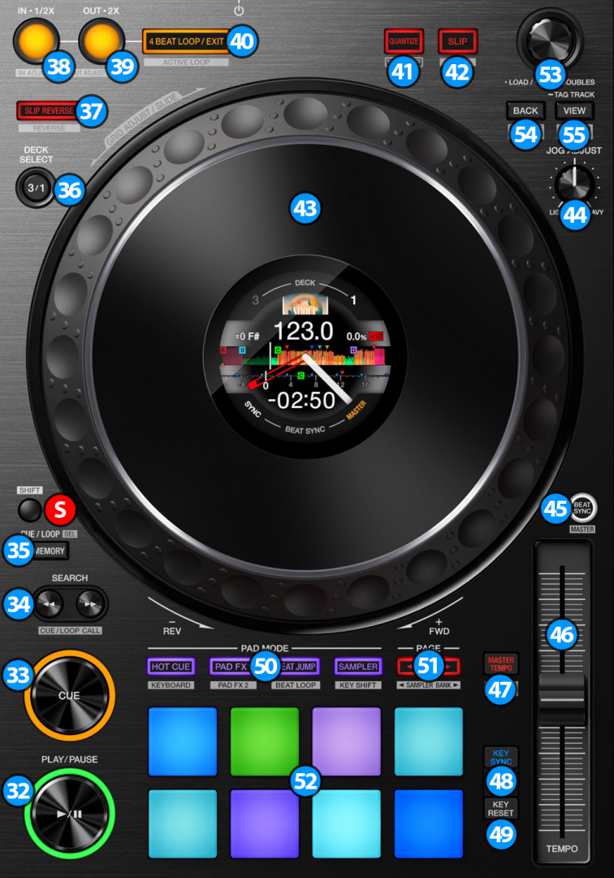

1. **PLAY/PAUSE**. Plays / Pauses the track. Press and hold **SHIFT** and then press this button to "stutter-play" the track from the last set Cue Point.
2. **CUE**. When the Deck is paused, you can set a temporary Cue Point by moving the Platter to place the Audio Pointer at the desired location and then pressing the Cue Button. During playback, you can press the Cue Button to return the track to this Cue Point. (If you did not set a Cue Point, then it will return to the beginning of the track.). If the Deck is paused, you can press and hold the Cue Button to play the track from the Temporary Cue Point. Releasing the Cue Button will return the track to the temporary Cue Point and pause it. To continue playback without returning to the Temporary Cue Point, press and hold the Cue Button, then press and hold the Play Button, and then release both buttons.  
   Hold down **SHIFT** and then press this button to return to the beginning of the track.
3. **SEARCH**: Use these buttons to move track backwards/forward by 4 beats. Keep the buttons pushed for continuous seeking
4. **MEMORY**: Use this button to save (and enable) a Loop at the current position to the 1st (default) Saved Loop slot. When a track has a Saved Loop at the default slot, use this button to enable the Loop at its saved position. Track will jump to this position if current position is later to the Saved Loop, and will not jump if earlier.

**S** **SHIFT**. Press and hold this button to access secondary functions (black lettering in gray box) of other controls on the DDJ-1000

1. **DECK SELECT.** Switch Left decks (1 and 3) and Right Decks (2 and 4).
2. **SLIP REVERSE**. Press and hold this button to play the track backwards. On release the track will continue from the position it would have been if the button was never pressed. Hold down **SHIFT** and press this button (momentarily) to play the track backwards. Press again to return to forward direction.
3. **LOOP IN**. Use this button to set a Loop In point (for manual looping). If a loop is active use this button to halve the length of the current loop.  
   Hold down **SHIFT** and press this button while a loop is active in order to use the jog for fine-tuning the loop-in point (loop in adjust). While the jog is in fine-tuning mode press this button once again (or exit the loop) for the jog to return to it's normal operation.
4. **LOOP OUT**. Use this button to set a Loop Out point (for manual looping). If a loop is active use this button to double the length of the current loop.  
   Hold down **SHIFT** and press this button while a loop is active in order to use the jog for fine-tuning the loop-out point (loop out adjust). While the jog is in fine-tuning mode press this button once again (or exit the loop) for the jog to return to it's normal operation.
5. **4 BEAT LOOP/EXIT**. Use this button to activate an automatic 4 beat loop. If a loop is active use this button to exit the loop  
   Hold down **SHIFT** and press this button to activate a Saved Loop.
6. **QUANTIZE**. Press this button to toggle Quantize on/off. When Quantize is enabled, setting loops, jumping between hot cue points and starting playback of the deck will snap to the grid (CBG) of the track.
7. **SLIP.** Enables Slip Mode. Several software functions (such as Jogwheel movements, HotCues and Loops) will apply temporary on the track, and the track will return to the position it would have been if those functions were not triggered. Hold down **SHIFT** and press this button to toggle between the Scratch and Bend Jogwheel modes.
8. **JOGWHEEL**. Pressure sensitive platter for scratching (Vinyl Mode) or bending (CD Mode).
9. **JOG FEELING ADJUST**. Adjust the tension of the jogwheel (hardware operation)
10. **SYNC**. Press this button to automatically match the corresponding Deck's tempo with the opposite Deck's (or the Master Deck’s if using a 4 decks Skin) tempo and phase. Hold down **SHIFT** and press this button to set this deck as Master Deck (for 4 decks skins).
11. **TEMPO**. Controls the track's playback tempo.
12. **MASTER TEMPO**. Press this button to "lock" the track's pitch to its original key. The track's tempo will remain at the speed designated by the Pitch Fader. Hold down **SHIFT** and press this button to cycle through the available pitch ranges (6%, 10%, 16% and 100%)
13. **KEY SYNC**. Press this button to match the musical Key of the track with the Key of the Master deck (or the other deck if using a 2 decks skin). The change of the Key will be the smallest required to make it compatible with the other Key.
14. **KEY RESET**. Press this button to reset the musical Key of the track to it's original value.
15. **PAD MODE**. Switch the pads of the unit to various modes (see [PADS](https://www.virtualdj.com/manuals/hardware/pioneer/ddj1000/layout/pads.html))
16. **PAGE/PARAMETERS**. Offer various operations, depending on the PADs Mode (see [PADS](https://www.virtualdj.com/manuals/hardware/pioneer/ddj1000/layout/pads.html))
17. **PADS**. Offer various operations, depending on the PADs Mode (see [PADS](https://www.virtualdj.com/manuals/hardware/pioneer/ddj1000/layout/pads.html))

**[BROWSER CONTROLS](https://www.virtualdj.com/manuals/hardware/pioneer/ddj1000/layout/decks.html" \l "browser)**

1. **BROWSE**.  
   **Turn:** Scrolls through files or folders.  
   **Push**: If focus is on the Folders list press the knob to set focus on the Songs list. If focus is on the Songs list, press once to load the selected track on the deck, or press twice (double-click) to clone the track from the other deck to this deck.  
   Hold down **SHIFT** and press the knob down to display the VirtualDJ Browser in zoom state.
2. **BACK**. Press this button to set focus to the Folders list. If focus is on Folders list, use this button to expand/collapse sub-folders.  
   Hold down **SHIFT** and press this button to add the selected track on the current playlist.
3. **VIEW**. Press this button to set focus to the Sideview list. If focus is on Sideview list, press this button to set focus back to Songs list.  
   Hold down this button for one second to show/hide the track info panel.  
   Hold down **SHIFT** and press this button to cycle though the available Sideview lists (Automix, Sidelist, Karaoke, Sampler and Clone).

**[ON JOG DISPLAY](https://www.virtualdj.com/manuals/hardware/pioneer/ddj1000/layout/decks.html" \l "jogdisplay)**

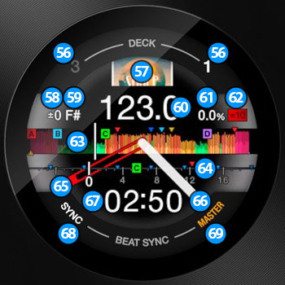

1. **DECK**. Shows the current deck assignment for the deck controls.
2. **COVER**. Displays the cover art of the track.
3. **KEY ADJUSTMENT**. Shows the musical Key adjustment applied on the track.
4. **CURRENT KEY**. Shows the current musical Key of the track.
5. **CURRENT BPM**. Shows the current BPM (Beats Per Minute) of the track.
6. **PITCH ADJUSTMENT**. Shows the current pitch adjustment of the track.
7. **PITCH RANGE**. Shows the pitch range that can be used by the Tempo Slider.
8. **WAVEFORM**. Displays the track's waveform among with the location of the track's hotcues.
9. **CUE SCOPE**. Displays the grid (CBG) of the track, among with the location of the track's hotcues.
10. **CUE STICKER POSITION**. Marks the location of the current cue.
11. **JOG ROTATION STICKER**. Shows the rotation of the jog.
12. **TIME DISPLAY**. Shows the elapsed or remain time of the track.
13. **SYNC**. Turns on when the track loaded on this deck is in sync with the track of the Master deck
14. **MASTER**. Turns on when the current deck is selected as the Master deck.

**MIXER & EFFECTS**

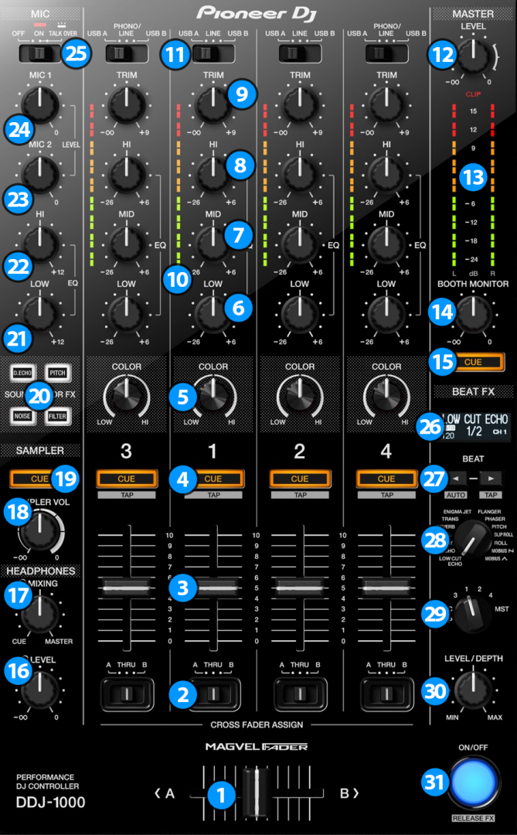

**[MIXER CONTROLS](https://www.virtualdj.com/manuals/hardware/pioneer/ddj1000/layout/mixer.html" \l "mixer)**

1. **CROSSFADER**. Blends audio between the channels assigned to the left and right side of the crossfader.
2. **CROSSFADER CH ASSIGN**. Define if a mixer channel will be output regardless of the position of the crossfader (THRU position) or Left/Right.
3. **VOLUME**. Adjust the Volume of each channel. While **SHIFT** is held down, the VOLUME faders will stop the deck at the previously selected Cue when these reach the minimum level (zero) and will start the deck (synced to the other deck) if those move from the zero position. (Fader Start)
4. **CUE (PFL)** (per channel) Press these buttons to send each channel to the Headphones Output channel.
5. **COLOR FX PARAMETER**. Adjust the parameter of the selected COLOR FX for each channel. When in middle position, the COLOR FX has no effect on the sound.
6. **LOW EQ**. Adjust the Low frequencies for each mixer channel.
7. **MID EQ**. Adjust the Mid frequencies for each mixer channel.
8. **HI EQ**. Adjust the High frequencies for each mixer channel.
9. **TRIM**. Adjust the Gain of each mixer channel. Note that the "zero gain / park" position is 12 o clock.
10. **CH INPUT VUMETER**. Shows each channels input (pre fader) volume.
11. **INPUT SELECTORS**. Define the source of each Channel. Put the switchers to **USB A** or **USB B** position for software mixing.
12. **MASTER VOLUME**. Adjust the level of the Master Output. Hardware operation but movement visible on the VirtualDJ GUI
13. **MASTER OUTPUT VUMETER**. Shows the master output volume of the unit. Hardware operation.
14. **BOOTH MONITOR**. Adjust the level of the Booth Output of the DDJ-1000. Hardware operation, not visible on the VirtualDJ GUI.
15. **MASTER CUE (PFL)**. Send the Master Output of the unit to the Headphones Output channel. Please note that in order to hear the Master Output on your headphones you must also turn the **HEADPHONES MIXING (17)** knob to the desired position.
16. **HEADPHONES VOLUME.** Adjust the volume of the Headphones Channel. Hardware operation, but movement visible on the VirtualDJ GUI.
17. **HEADPHONES MIXING.** Adjust how the Channels and the Master Output blend at the Headphones Channel. Hardware operation, but movement visible on the VirtualDJ GUI.
18. 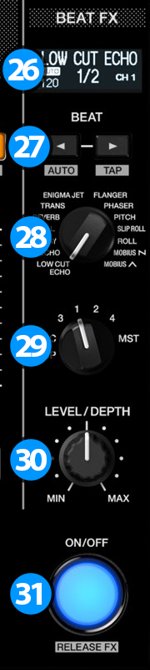 **SAMPLER VOLUME**. Adjust the Master Output Volume of the VirtualDJ Sampler
19. **SAMPLER PFL**. Send the sound of VirtualDJ Sampler to the Headphones Output channel.
20. **SOUND COLOR FX**. Select one of the predefined Color Effects (Dub Echo, Pitch, Noise and Filter).
21. **MIC LOW EQ.** Adjust the Low frequencies of MIC1 and MIC2 Inputs of the DDJ-1000 (Hardware operation)
22. **MIC HI EQ.** Adjust the High frequencies of MIC1 and MIC2 Inputs of the DDJ-1000 (Hardware operation)
23. **MIC 2 VOLUME.** Adjust the Volume Level of MIC2 Input of the DDJ-1000 (Hardware operation)
24. **MIC 1 VOLUME.** Adjust the Volume Level of MIC1 Input of the DDJ-1000 (Hardware operation)
25. **MIC CONTROL.** Turn ON and OFF the MIC1 and MIC2 Inputs of the DDJ-1000 or enable the auto Talk Over. (Hardware operation)

**[EFFECT CONTROLS](https://www.virtualdj.com/manuals/hardware/pioneer/ddj1000/layout/mixer.html" \l "effects)**

The BEAT FX section is used to apply Hardware or VirtualDJ effects to Decks/Master/Mic/Sampler, depending whether or not VirtualDJ is running. Hardware Effects will be applied when VirtualDJ is not running and VirtualDJ (software) effects will be applied when VirtualDJ is connected to DDJ-1000.\*  
***\*As of Firmware 1.05 released in June 2018 from Pioneer, hardware effects are always applied on analog sources, while software effects are always applied on digital sources. Devices with older firmware will not be able to use ANY effects on analog sources with the default mapper of VirtualDJ and will have to upgrade their Firmware to version 1.05 or greater.***

1. **BEAT FX LCD SCREEN:** Shows information about the selected effect.
2. **BEAT**: Use these buttons to half/double the Beats Parameter of the selected Effect (for the Effects that are beat-aware). The beats value is displayed on the LCD screen.
3. **BEAT FX SELECT**: Use this selector knob to select one of the available Beat FX. The name of the selected Effect is displayed on the LCD screen.
4. **BEAT FX ASSIGN**: Use this selector knob to select to which source the effect will apply to. (Decks, Master, Mic or Sampler). The selected source will be displayed on the LCD screen.
5. **BEAT FX LEVEL**: Use this knob to adjust the 1st Parameter of the selected Effect.
6. **BEAT FX ON**: Use button to enable/disable the selected Beat FX. Its led will flash when enabled

[PIONEER](https://www.virtualdj.com/manuals/hardware/pioneer.html) - [DDJ-1000](https://www.virtualdj.com/manuals/hardware/pioneer/ddj1000.html) - [LAYOUT](https://www.virtualdj.com/manuals/hardware/pioneer/ddj1000/layout.html)

**PERFORMANCE PADS**

The 8 Pads offer various functions, depending on the selected Pad mode. Each of the 4 Pad mode buttons offers 2 individual modes. One with the press of the mode button, and an additional mode with press of the mode button while **SHIFT** is held down. The 8 modes represent a page of the PADS section on the default VirtualDJ GUI.

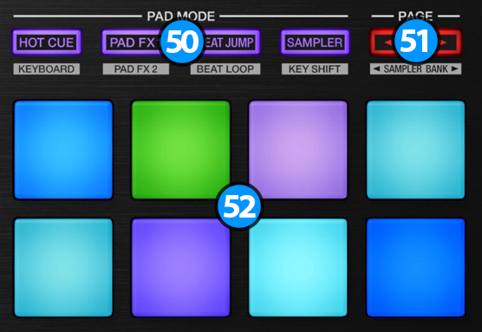

1. **PAD MODE**. Press any of the 4 available Pad mode buttons to set the Pads to Hotcues, PAD FX1, Beatjump and Sampler mode.  
   Hold **SHIFT** and then press any of the 4 available Pad mode buttons to set the Pads to Cue Loop, PAD FX2, Beat Loop and Keycue mode.
2. **PADS**. The 8 Pads offer different functionality depending on the selected mode.
3. **PAGE/PARAMETERS**. Depending on the selected mode, these buttons control the selected page or the parameters of the selected mode.

**[HOTCUES 16](https://www.virtualdj.com/manuals/hardware/pioneer/ddj1000/layout/pads.html" \l "hotcues)**

Press the **HOT CUE** mode button to set the PADs to Hot Cue mode (button will be lit purple) and automatically load the Hotcues 16 Pads page in VirtualDJ GUI  
  
The Hot Cues mode is divided to 2 sub pages. The first page will control hotcues 1-8 and the second page will control hotcues 9-16.  
In order to switch between the 2 different pages use the PAGE/PARAMETERS buttons.  
When the left PAGE button is lit, the first page is selected. When the right PAGE button is lit, the second page is selected.  
  
Each one of the 8 pads **assigns a Hot Cue Point, or jumps** the track to that Hot Cue Point (if assigned).  
When a Hot Cue Button is unlit, you can assign a Hot Cue Point by pressing it at the desired point in your track. Once it is assigned, the Hot Cue Button will light on.  
  
Hold **SHIFT** and then press a pad to **delete** its assigned Hot Cue Point.

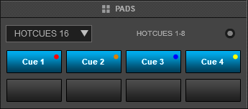

*Hotcues Pads Page 1 (Hotcues 1-8) – VirtualDJ GUI*

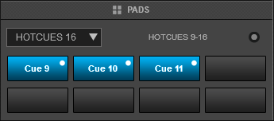

*Hotcues Pads Page 2 (Hotcues 9-16) – VirtualDJ GUI*

**[PAD FX1](https://www.virtualdj.com/manuals/hardware/pioneer/ddj1000/layout/pads.html" \l "padfx1)**

Press the **PAD FX1** mode button to set the PADs to PAD FX1 mode (button will be lit purple) and automatically load the PAD FX1 page in VirtualDJ GUI. The PAD FX1 Page is a custom page for the DDJ-1000 and will only be available if the unit is connected.  
  
Each one of the 8 pad **triggers a pre-defined Effect** as per the image on the side.  
  
**Pads 1-3** : Trigger the Echo Effect of 1/2, 1 and 2 beats size respectively.  
**Pad 4**: Triggers the Phaser Effect at 8 beats Speed.  
**Pads 5-7**: Trigger the Cut Effect of 1/4, 1/2 and 1 beats size respectively.  
**Pad 8**: Triggers the Flanger Effect at 8 beats Speed.

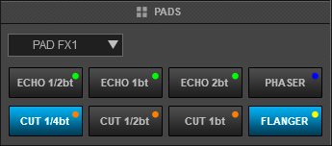

*PAD FX1 Pads Page – VirtualDJ GUI*

**[BEATJUMP MODE](https://www.virtualdj.com/manuals/hardware/pioneer/ddj1000/layout/pads.html" \l "beatjump)**

Press the **BEAT JUMP** mode button to set the PADs to Beat Jump mode (button will be lit purple) and automatically load the BeatJump Pads page in VirtualDJ GUI  
  
In this mode, each one of the Pads will **jump** the track backwards/forward by the amount of beats depending on the selected page/bank (from 1/8 beats to 32 bars)  
  
Use the PAGE/PARAMETERS buttons to **select**the previous/next **page** with the desired Beats sizes

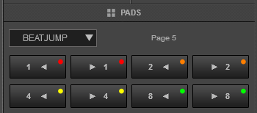

*Beatjump Page page*

**[SAMPLER](https://www.virtualdj.com/manuals/hardware/pioneer/ddj1000/layout/pads.html" \l "sampler)**

Press the **Sampler** mode button to set the PADs to Sampler mode (button will be lit purple) and automatically load the Sampler Pads page in VirtualDJ GUI  
  
Each one of the 8 pads **triggers a sample** from the selected Sampler Bank of VirtualDJ. If a bank has less than 9 samples, both sides of the DDJ-1000 will control the same samples. If a bank has more than 8 samples, the left side of the DDJ-1000 will control samples 1 to 8 and the right side samples 9 to 16.  
Press the pads to trigger a sample. Depending on the selected trigger Pad mode, use **SHIFT** and the same pads to **stop**the sample.  
Use the PAGE/PARAMETER buttons to select the **Sampler Bank** (previous/next).

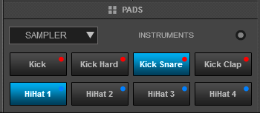

*Sampler Pads Page – VirtualDJ GUI*

**[CUE LOOP](https://www.virtualdj.com/manuals/hardware/pioneer/ddj1000/layout/pads.html" \l "cueloop)**

Hold down **SHIFT** and press the **HOT CUE** mode button to set the PADs to Cue Loop mode (button will be lit yellow) and automatically load the Cue Loop Pads page in VirtualDJ GUI  
  
In this mode each one of the 8 pads assigns a Hot Cue Point or jumps the track to that Hot Cue Point, but in both cases, **it also triggers a Loop** at that point (momentary or toggle depending on the selected mode from the Page menu).  
  
Hold **SHIFT** and then press a pad to stutter/jump to the Hotcue (loop will remain triggered)  
  
Use the PAGE/PARAMETER buttons to half/double the size of the triggered Loop.  
Hold **SHIFT** and then use the PAGE buttons to select the On/Off (Toggle) or Hold (momentary) Loop trigger mode.

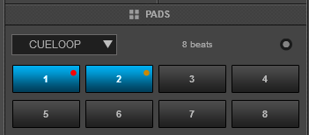

*Cue Loop Pads Page – VirtualDJ GUI*

**[PAD FX2](https://www.virtualdj.com/manuals/hardware/pioneer/ddj1000/layout/pads.html" \l "padfx2)**

Hold down **SHIFT** and press the **PAD FX1** mode button to set the PADs to PAD FX2 mode (button will be lit yellow) and automatically load the PAD FX2 page in VirtualDJ GUI. The PAD FX2 Page is a custom page for the DDJ-1000 and will only be available if the unit is connected.  
  
Each one of the 8 pad **triggers a pre-defined Effect** as per the image on the side.  
  
**Pads 1-3** : Trigger the Loop Roll Effect of 1/4, 1/2 and 1 beats size respectively.  
**Pad 4**: Triggers the Reverb Effect.  
**Pads 5-7**: Trigger the 1st, 4th and 5th bank of Beat Grid Effect respectively.  
**Pad 8**: Triggers the BrakeStart Effect.

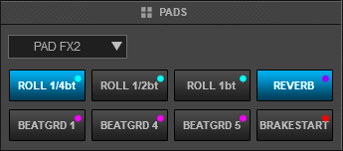

*PAD FX2 Pads Page – VirtualDJ GUI*

**[LOOP](https://www.virtualdj.com/manuals/hardware/pioneer/ddj1000/layout/pads.html" \l "beatloop)**

Hold down **SHIFT** and press the **BEAT JUMP** mode button to set the PADs to Loop mode (button will be lit yellow) and automatically load the Loop Pads page in VirtualDJ GUI  
  
Press one of the pads to **trigger an Auto Loop** of a different size in beats, depending on the selected page. There are 6 different pages available with sizes starting from 1/32 up to 128 beats.  
  
Use the PAGE/PARAMETER buttons to select the previous/next page with the desired Loop sizes  
Hold **SHIFT** and then use the PARAMETER buttons to change the behavior of the Loop pads, by selecting the On/Off (toggle), Hold (momentary – while pad is pressed) or the Roll mode (track will resume to the position it would have been once the pad is released)

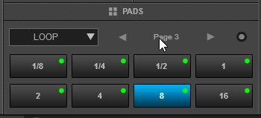

*Loop Pads Page – VirtualDJ GUI*

**[KEY CUE](https://www.virtualdj.com/manuals/hardware/pioneer/ddj1000/layout/pads.html" \l "keycue)**

Hold down **SHIFT** and press the **SAMPLER** mode button to set the PADs to KeyCue mode (button will be lit yellow) and automatically load the KeyCue Pads page in VirtualDJ GUI

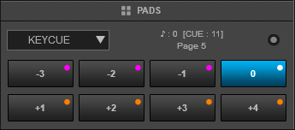

*KeyCue Page - VirtualDJ default skin*

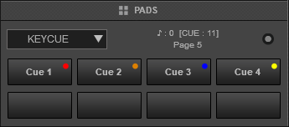

*KeyCue Page when SHIFT is pressed - VirtualDJ default skin*

In this mode, the Pads trigger a selected Hotcue point (or the Temporary Cue if none selected or not available) at a selected Key semitone (from -7 to +7).  
  
8 different pages/banks are offered with various semitone values to use and a 0 value (reset key to tis original value) is always offered in all pages.  
Hold **SHIFT** and then **select a Hotcue** for the Key pads to trigger. Each time a Pad is pressed, the track will jump to that Hotcue point and will also alter the Key of the track to the value designated by it assigned value.  
  
Use the PAGE/PARAMETER buttons to **adjust the Key** of the track without trigger a Hotcue.  
Hold down **SHIFT** and use the PAGE/PARAMETERS buttons to select a different **page/bank** with different key semitone values.  
  
Read further details about Pads in the [VirtualDJ 8 manual](https://www.virtualdj.com/manuals/virtualdj8/interface/decks/decksadvanced/pads/index.html" \t "_blank)

[PIONEER](https://www.virtualdj.com/manuals/hardware/pioneer.html) - [DDJ-1000](https://www.virtualdj.com/manuals/hardware/pioneer/ddj1000.html) - [LAYOUT](https://www.virtualdj.com/manuals/hardware/pioneer/ddj1000/layout.html)

**FRONT - REAR**

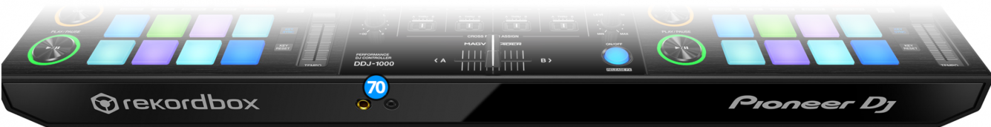

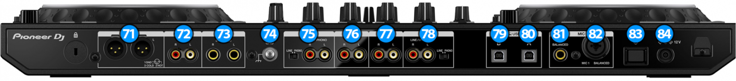

1. **HEADPHONES CONNECTOR**: Connect your headphones. Both sizes (3.5mm and 6.35mm ( 1⁄4 in)) are offered.
2. **MASTER OUT1**: Master signal output connectors (XLR – Balanced). Use this to connect on your pro grade amplifier or self-powered speakers.
3. **MASTER OUT2**: Master signal output connectors (RCA – Unbalanced). Use it to connect with another mixer, or consumer grade amplifier.
4. **BOOTH OUT**: Booth signal output (TRS – Balanced). The strength of the signal is controlled by “**BOOTH MONITOR LEVEL**” knob **(14)** on the mixer section. Use it to connect your booth speakers, or an amp that needs different sound output level than master output.
5. **GND SCREW**: Use it to screw your GND (ground) cable from turntables that provide it in order to eliminate GND static noise.
6. **CH4 INPUTS**: Connect an analog source on CH4 of the DDJ-1000 mixer. You can connect a turntable or a CD-Player. The input is selectable via “**INPUT SELECT SWITCH**” **(11)** on the mixer section
7. **CH2 INPUT**: Connect an analog source on CH2 of DDJ-1000 Mixer. You can only connect a CD-Player, or a similar line level device.
8. **CH1 INPUT**: Connect an analog source on CH1 of DDJ-1000 Mixer. You can only connect a CD-Player, or a similar line level device.
9. **CH3 INPUTS**: Connect an analog source on CH3 of the DDJ-1000 mixer. You can connect a turntable or a CD-Player.
10. **USB B CONNECTOR**: Use a standard USB cable to connect DDJ-1000 with your computer.
11. **USB A CONNECTOR**: Use a standard USB cable to connect DDJ-1000 with your computer.
12. **MIC 2 INPUT**: Connect a mic on the DDJ-1000 mixer. You can use only a Jack (TRS) connector.
13. **MIC 1 INPUT**: Connect a mic on the DDJ-1000 mixer. You can use XLR or Jack (TRS) connectors.
14. **POWER SWITCH**: Turns on/off the power on the device. Please turn on the device only after doing and securing all connections on the back.
15. **DC INPUT**: Connect the supplied PSU.

[PIONEER](https://www.virtualdj.com/manuals/hardware/pioneer.html) - [DDJ-1000](https://www.virtualdj.com/manuals/hardware/pioneer/ddj1000.html)

**ADVANCED AUDIO OPTIONS**

Pioneer DDJ-1000 offers a variety of Inputs and Operation modes. The unit can operate **both** as MIDI and a stand-alone hardware mixer **at the same time**, allowing mixing from analogue media sources (CD Players, Turntables etc) connected to one of the 4 available inputs at the rear panel, along with the ability to use a Computer DJ Application.

**[MIXER CHANNELS](https://www.virtualdj.com/manuals/hardware/pioneer/ddj1000/advancedaudio.html" \l "mixerchannels)**

**Channel 3**(far left) :  
Audio signal from an analogue source (such as a standard CD Player or Turntable) connected to the CH 3 inputs at the rear panel can be inserted and processed by the mixer when the switcher at the top panel is set to **Phono/Line** position.  
When using the CH3 inputs, please make sure that you set the corresponding switcher on the rear of the device to the proper position (line/phono) depending on the type of the connected audio equipment.  
Audio signal from VirtualDJ Deck 3 can be routed to this Channel when the switcher at the top panel is set to USB A or USB B position (depending on which USB port your computer is connected to)  
  
**Channel 1** (middle-left) :  
Audio signal from an analogue **line level** source (such as a standard CD Player) connected to the CH 1 LINE inputs at the rear panel can be inserted and processed by the mixer when the switcher at the top panel is set to **Line** position.  
Audio signal from VirtualDJ Deck 1 can be routed to this Channel when the switcher at the top panel is set to USB A or USB B position (depending on which USB port your computer is connected to)  
  
**Channel 2** (middle-right) :  
Audio signal from an analogue line level source (such as a standard CD Player) connected to the CH 2 LINE inputs at the rear panel can be inserted and processed by the mixer when the switcher at the top panel is set to **Line** position.  
Audio signal from VirtualDJ Deck 2 can be routed to this Channel when the switcher at the top panel is set to USB A or USB B position (depending on which USB port your computer is connected to)  
  
**Channel 4** (far right) :  
Audio signal from an analogue source (such as a standard CD Player or Turntable) connected to the CH 4 inputs at the rear panel can be inserted and processed by the mixer when the switcher at the top panel is set to **Phono/Line** position.  
When using the CH4 inputs, please make sure that you set the corresponding switcher on the rear of the device to the proper position (line/phono) depending on the type of the connected audio equipment.  
Audio signal from VirtualDJ Deck 4 can be routed to this Channel when the switcher at the top panel is set to USB A or USB B position (depending on which USB port your computer is connected to)  
  
Notes :  
- Each time a different source is selected from the top switchers, the audio signal of other sources on the same channel will be muted.  
- Switch between various sources is smooth, providing the ability of back-to-back dj changeover.

**[RECORDING & BROADCASTING](https://www.virtualdj.com/manuals/hardware/pioneer/ddj1000/advancedaudio.html" \l "recording)**

The unit offers the ability to record the Master Output along with the Microphone and LINE Inputs directly from VirtualDJ record button (in the MASTER center panel). The dedicated Recording input channel is already pre-configured, so no further adjustments need to be done.

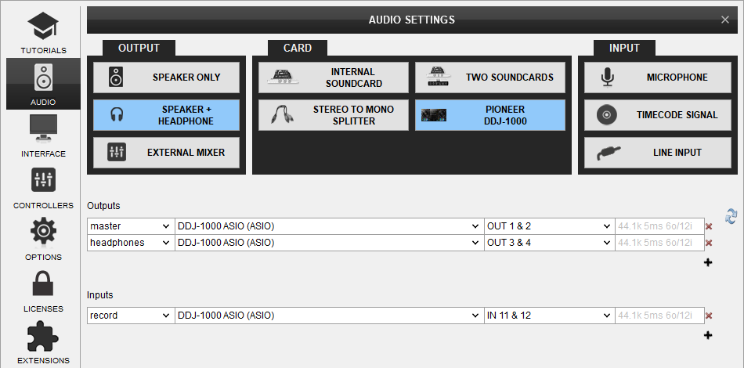

 The recorded output includes any source routed to the Mixer, including analogue media sources connected to the LINE or PHONO Inputs when the top switchers are set to the relative position.

**[TIMECODES (DVS)](https://www.virtualdj.com/manuals/hardware/pioneer/ddj1000/advancedaudio.html" \l "timecodes)**

DDJ-1000 offers DVS (Timecoded CDs and Vinyls) Support.  
Depending on whether you use Timecode Vinyl (Turntables) or Timecode CDs (CD Players) please perform the following steps:

* Connect your Turntables to CH 3 and/or CH 4. If you use CD Players connect them to any of the available CH inputs Inputs.
* Place the Input switches on the top panel to **USB A** or **USB B** position for the related Mixer Channels (depending on which USB port your computer is connected to)
* Open VirtualDJ Settings ->AUDIO tab ans press the TIMECODE SIGNAL button from the INPUT tab
* Select the correct audio channels:  
  For Turntables use 5&6 for Channel 3 and 7&8 for Channel 4  
  For CD Players use 1&2 for Channel 1 and 3&4 for Channel 2
* Click to APPLY

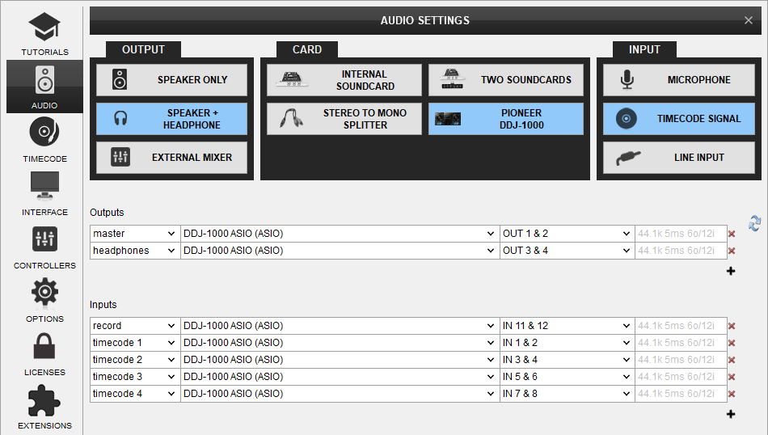

*Audio configuration with Timecode Inputs*

Use the TIMECODE On/Off buttons that will be offered on the Decks (or in the SCRATCH panel for the 4 Decks default VirtualDJ GUI) to enable/disable Timecode control or use the Timecode signal to control a different Deck (e.g. swap Timecode control for Left decks when the 4 Decks GUI is selected)  
By default you would use Timecode Vinyls to control decks 3 & 4 and Timecode CD's to control deck 1 & 2  
If you want to use Timecode Vinyls to control decks 1 & 2 instead then you should create the following audio setup:

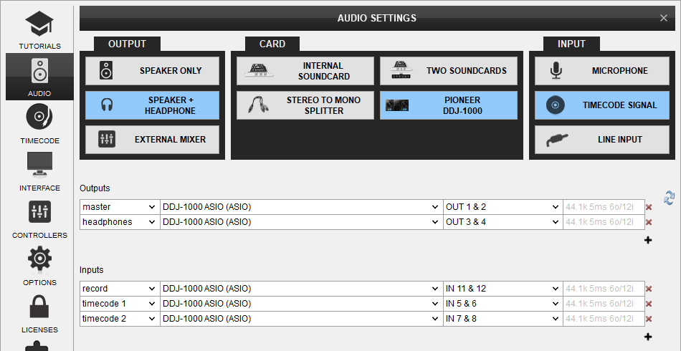

*Audio configuration with Timecode Vinyls (Turntables) controlling deck 1 & 2*

With this setup all the Input switchers on top of the mixer should be set on the same USB port that your computer is connect to.

**[LINE INS](https://www.virtualdj.com/manuals/hardware/pioneer/ddj1000/advancedaudio.html" \l "lineins)**

The LINE Inputs can be also used to send audio signal from an analogue media source connected at the rear panel to VirtualDJ for processing.

* Connect your analogue media devices to one of the available LINE inputs. If you connect a source on Line 3 and/or Line 4 input, remember to switch the Line/Phono switcher to Line position for that channel(s)
* Place the Input switches on the top panel to **USB A** or **USB B** position on your mixer channels depending on with port your computer is connected at.
* Open VirtualDJ Settings ->AUDIO tab and press the LINE INPUT button from the INPUT tab
* Click to APPLY

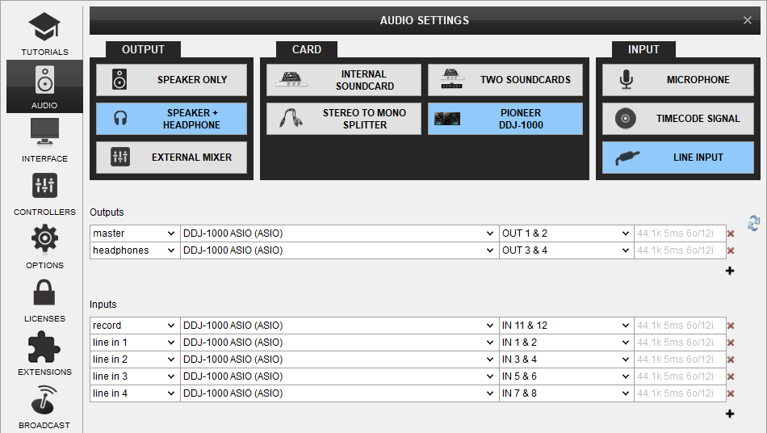

*Audio configuration with Line Inputs*

Use the LINE IN On/Off buttons that will be offered on the Decks (or in the SCRATCH panel for the 4 Decks default VirtualDJ GUI) to enable/disable Line In routing to a VirtualDJ deck.  
This will provide the ability to synchronize BPM with other decks, use Effects etc.

**[MICROPHONE INPUTS](https://www.virtualdj.com/manuals/hardware/pioneer/ddj1000/advancedaudio.html" \l "mics)**

DDJ-1000 offers 2 Microphone Inputs and Level/EQ controls from the top panel. Both audio signals from these inputs are directly routed to the Master Output of the unit.  
The Microphone inputs are not part of the USB Audio interface, so these cannot be added in VirtualDJ Audio setup and will not control the software Microphone section in the MASTER panel of VirtualDJ GUI and vice versa.  
  
However, as mentioned in the Recording section, both Microphone Inputs can be recorded via the REC button of VirtualDJ via the dedicated recording input channel of the Audio interface.

[PIONEER](https://www.virtualdj.com/manuals/hardware/pioneer.html) - [DDJ-1000](https://www.virtualdj.com/manuals/hardware/pioneer/ddj1000.html)

# CONTROLLER SETTINGS & OPTIONS

Pioneer DDJ-1000 offers a variety of settings and options regarding it's operation.  
You can change these settings by using a special **PAD Page** named "DDJ1K Settings". You can access this pad page via VirtualDJ GUI, or by holding down the **HOTCUE** pad mode button for more than one second.  
Please note that this pad page is accessible only when DDJ-1000 is connected to VirtualDJ. Use the PAGE/PARAMETERS buttons to cycle through the available pages.

## [LCD BRIGHTNESS](https://www.virtualdj.com/manuals/hardware/pioneer/ddj1000/settings.html" \l "lcdbrightness)

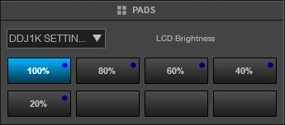

Press one of the pads to adjust the brightness of the on jog LCD display. Five levels of brightness are offered.

## [JOG BRIGHTNESS](https://www.virtualdj.com/manuals/hardware/pioneer/ddj1000/settings.html" \l "jogbrightness)

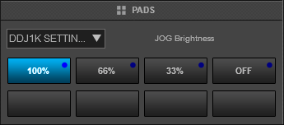

Press one of the pads to adjust the brightness of JOG ring leds. Three levels of brightness are offered, among with an option to turn the leds off completely.

## [LCD OPTIONS](https://www.virtualdj.com/manuals/hardware/pioneer/ddj1000/settings.html" \l "lcdoptions)

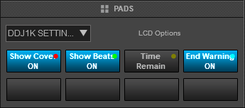

Press the 1st pad to toggle Cover art display on/off  
Press the 2nd pad to toggle "Cue Scope" display on/off  
Press the 3rd pad to toggle the displayed time between elapsed and remain time modes  
Press the 4th pad to toggle the track end warning on/off (when track end warning is active the leds of the JOG ring will blink on the last 30 seconds of the track)

## [MIC OPTIONS](https://www.virtualdj.com/manuals/hardware/pioneer/ddj1000/settings.html" \l "micoptions)

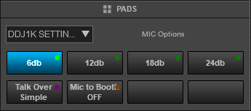

Press one of the first four pads to adjust the desired level of **Talk Over** level.  
Press the 5th pad to toggle between the two available Talk Over modes (Simple & Advanced)  
Press the 6th pad to set whether or not the sound of the MIC should be sent on BOOTH output as well.  
  
*For more information regarding the Talk Over functionality of the device and the available modes, please read the unit's operational manual.*

## [BOOTH OPTIONS](https://www.virtualdj.com/manuals/hardware/pioneer/ddj1000/settings.html" \l "boothoptions)

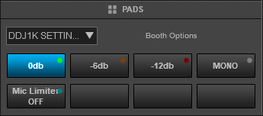

Press one of the first 3 pads to set the desired level attenuation for the **Booth** Output.  
Press the 4th pad to toggle the Booth Output between Stereo and Mono output modes.  
Press the 5th pad to toggle a limiter for the MIC level sent to Booth Output on/off

## [MASTER OPTIONS](https://www.virtualdj.com/manuals/hardware/pioneer/ddj1000/settings.html" \l "masteroptions)

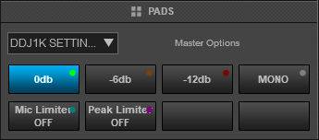

Press one of the first 3 pads to set the desired level attenuation for the **Master** Output.  
Press the 4th pad to toggle the Master Output between Stereo and Mono output modes.  
Press the 5th pad to toggle a limiter for the MIC level sent to Master Output on/off  
Press the 6th pad to toggle a peak limiter for the Master Output on/off

## [DEMO MODE](https://www.virtualdj.com/manuals/hardware/pioneer/ddj1000/settings.html" \l "demomode)

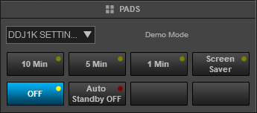

Press one of the first 3 pads to set the desired time after which the unit will enter "*Demo Mode*" if no activity is detected.  
Press the 4th pad to set the "Demo Mode" to screensaver mode.  
Press the 5th pad to turn off "Demo Mode" completely  
Press the 6th pad to toggle the Auto Standby feature of the device on/off.  
  
*For more information regarding "Demo Mode" and the Auto Standby feature, please read the unit's operational manual*

## [MISCELLANEOUS](https://www.virtualdj.com/manuals/hardware/pioneer/ddj1000/settings.html" \l "miscellaneous)

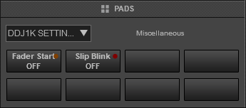

Press the 1st pad to toggle "Fader Start" feature on/off. When Fader Start is enabled, holding down SHIFT button while moving the volume faders will start or stop the deck depending on the movement of the volume fader.  
Press the 2nd pad to toggle "Slip Blink" feature on/off. When Slip Blink is enabled, activating slip mode will make the pads and jog leds to flash in order to indicate that their action is now temporary.

For further Technical features and specifications, visit

[PIONEER](https://www.virtualdj.com/manuals/hardware/pioneer.html) - [DDJ-1000](https://www.virtualdj.com/manuals/hardware/pioneer/ddj1000.html)

# INSTALLATION

## FIRMWARE & DRIVERS

**Firmware**: Update the firmware of the unit to the latest version from **[Pioneer Dj](https://www.pioneerdj.com/en/support/software/ddj-1000/" \l "firmware-update" \t "_blank)**  
  
**Drivers**: Install the latest drivers (for both **Windows** and **MacOS X** computers) from **[Pioneer Dj](https://www.pioneerdj.com/en/support/software/ddj-1000/" \l "drivers" \t "_blank)**

## VIRTUALDJ 8 SETUP

Download and install VirtualDJ 8 from our [**Downloads Page**](http://www.virtualdj.com/download/index.html)  
(in case you have not done already)  
  
Once VirtualDJ 8 is launched, a Login Window will appear. Login with your virtualdj.com account credentials. A **Pro Infinity** or a **Pro Subscription** License is required to fully use the Pioneer DDJ-1000  
  
Without any of the above Licenses, the controller will operate for 10 minutes each time you restart VirtualDJ.  
[**Buy a license**](http://www.virtualdj.com/buy/index.html)

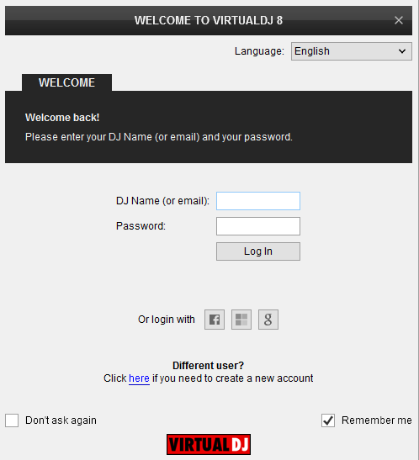

A detection window will appear next verifying proper connection with the DDJ-1000.  
  
Click on the "**Use Soundcard**" button for VirtualDJ to apply the predefined audio setup with the built-in sound card of the DDJ-1000. You can still change that from Settings->AUDIO tab.  
  
Click to **OK**.

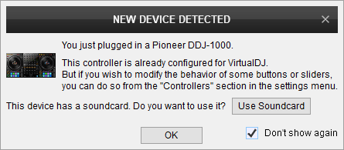

**The unit is now ready to operate.**

## ADVANCED SETUP

**MIDI Operation**  
The unit should be visible in the CONTROLLERS tab of Config and the “factory default” should be available/selected from the Mappings drop-down list. The factory default Mapping offers the functions described in this Manual, however those can be adjusted to your needs via VDJ Script actions.

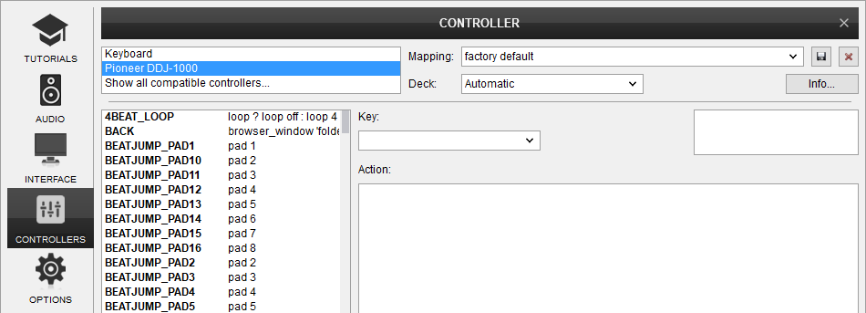

Find more details at  
[**VDJ Pedia**](http://www.virtualdj.com/wiki/VDJ8script.html)

## AUDIO SETUP

The unit has a pre-defined Audio setup and a special button in the AUDIO tab of Config to provide that. Alternative Audio setups can be applied in the same window.



For further software settings please refer to the **[Manuals](http://www.virtualdj.com/manuals/index.html" \t "_blank)** of VirtualDJ 8